|  |  |  |  |
| --- | --- | --- | --- |
| *Data Change Form* | | | |
| Reason for request | |  | |
| 115 | | | |
| Details of request | |  | |
| 115  This change has been done with reference to the Guidence Note: GUI_00000097488 (Guidance Note - SAP ABAP Routine Changes) | | | |
| **Up Versioning History** | | | |
| N/A | | | |
| **Change Completed by GERP:** | | |  |
| **Print Name** | | **AutoSAP Automation** | |  |
| **Date *(dd-mmm-yy*):** | | **23-58-25** | |  |
| **Tel No *(site & ext):*** | | 0091-80-67255575 | |

|  |  |  |  |  |
| --- | --- | --- | --- | --- |
| **Attachments to this form?** |  | **If Yes, specify number of pages attached** | **4** | **pages** |
| *(Tick required option)* |  | *If Yes, Change Control number to be on each page; “Page X of Y” on each page* | | |
| **List Exhibits Attached:** | | | | |
| A. Before change screen exhibit | | | | |
| B. Before agents screen | | | | |
| C. After agents screen | | | | |
| D. After change screen exhibit | | | | |

### A before 445511.png

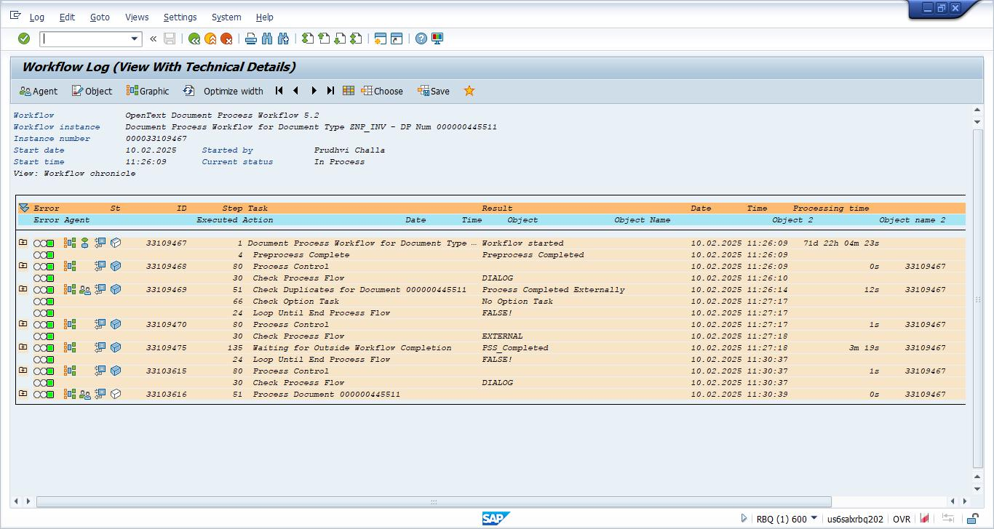

### B beforeagents 445511.png

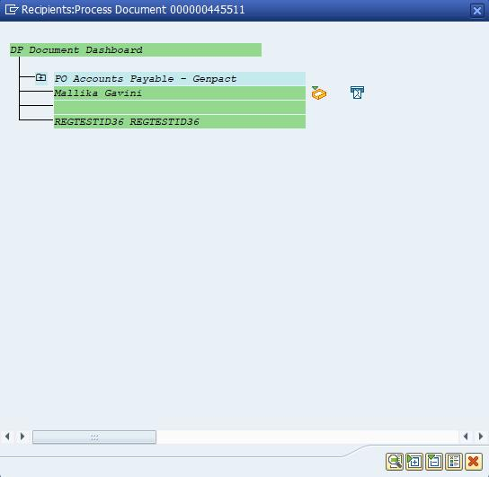

### C afteragents 445511.png



### D after 445511.png

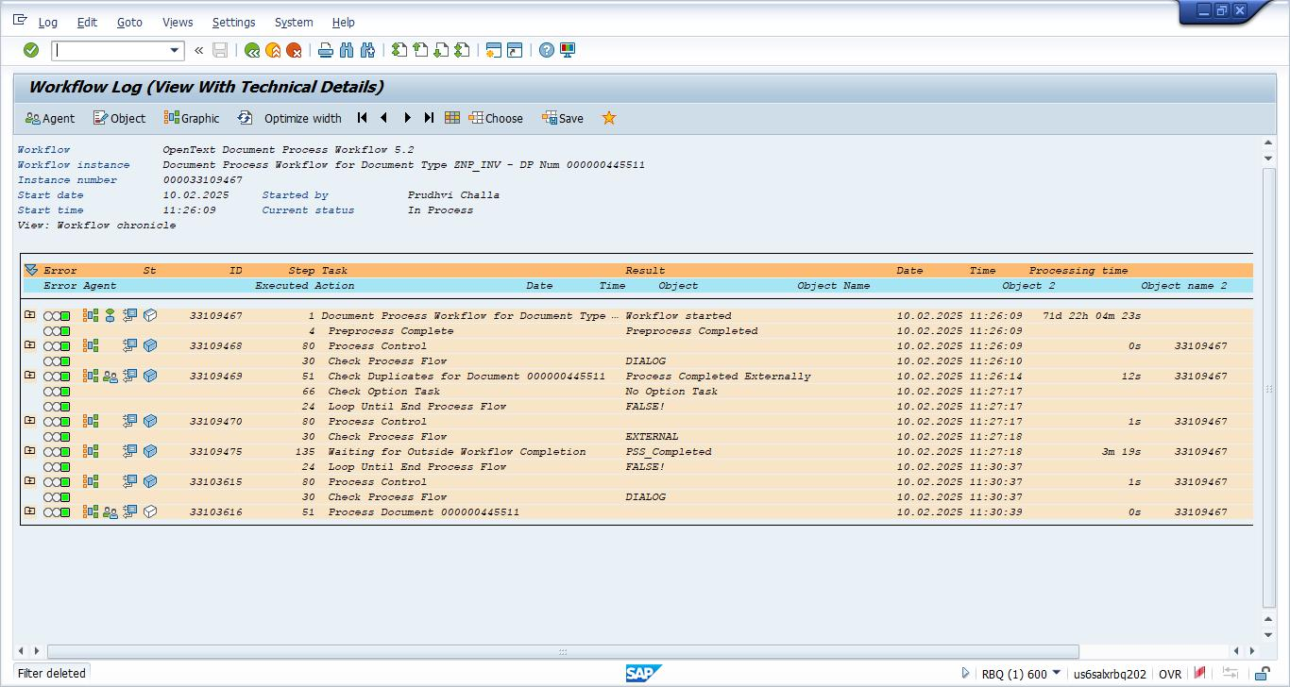

### DPstatus.png

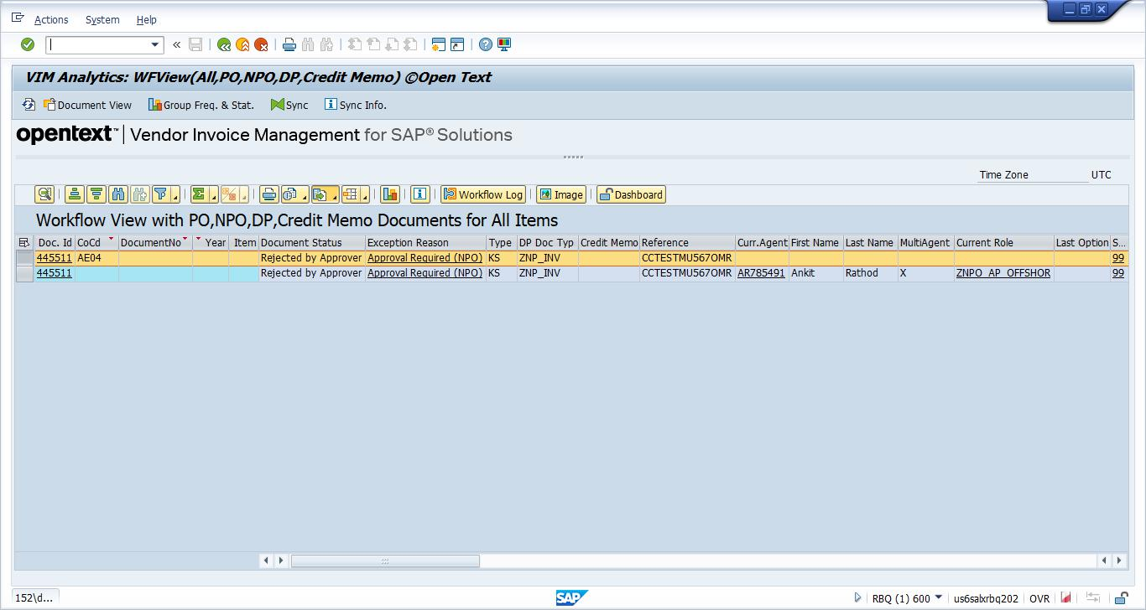

### F action 445511.png

